
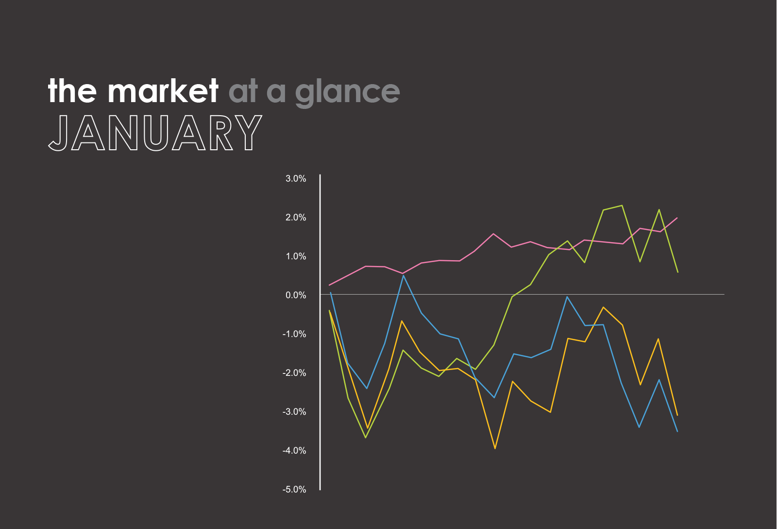


- After much anticipation, the European Central Bank announced it will pursue a €1T bond-buying program that will run from early 2015 to late 2016. It is hoped that the change in monetary policy will be able to restart growth in Eurozone countries, which collectively make up the world’s largest economy.
Past performance is no guarantee of future results. Indices are unmanaged and cannot be invested into directly.
U.S. Large Cap
(Dow Jones Industrial Average)
17,164.95 (-3.69%)
U.S. Mid/Small
(Russell 2000)
1,165.39 (-3.26%)
Foreign Large
(MSCI EAFE Index Fund)
61.22 (0.62%)
Bond Market
(Barclays Aggregate Bond Fund)
112.38 (2.05%)

The market in action
- The U.S. Department of Labor reports that total employment in the country increased by 2.95M in 2014; this marked the largest one-year jobs increase for the country since 1999.
- The Swiss National Bank surprises the world by ending its currency peg with the Euro. Following the announcement, the Swiss Franc, which is viewed as one of the most secure currencies in the world, leapt 30 percent in value against the Euro.
- The Federal Reserve reports that consumer debt (not including mortgages) increased by $14.1B in November, pushing it to a record high total of $3.3T. Though credit card debt actually fell during the month, student debt and auto loans climbed significantly.
- Apple crushes earnings estimates by 37 percent and posts the best corporate quarterly profits in history. The tech giant brought in around $18B in profits during the last quarter of 2014—over 10 percent higher than the previous corporate record (OAO Gazprom, Q1 2011).
- Reports show that the purchase of durable goods in the United States missed its anticipated 0.3 percent growth in December by a wide margin, posting a 3.4 percent drop from the previous month.
- U.S. home construction increased to 1.01M in 2014, 9 percent higher than the previous year. Home construction still remains far below the 2005 housing bubble high of 2.07M single-family homes per year.
CAISSA Market Take
This time last year the market was worried about an emerging markets meltdown and the impact of the Federal Reserve pullback on so-called quantitative easing. The markets priced the end of the bond purchasing into the markets early and therefore the end had very little effect on the market as a whole. This January, investors are worried about cheap oil and the global economic slowdown.

The energy and financial sectors were the biggest losers for the month of January. Oil fell below $50 for first time early in the month and acted as a psychological trigger that spooked investors. This was followed up by earnings reports and announcements from Big Oil showing major cutbacks in spending and operations. There's little doubt that it will be a leaner year ahead in the energy sector.

Financials were a bigger surprise. The big bank CEOs blamed Washington regulations for sluggish performance, but the reality is many bank's core investment banking and trading have been suffering.
There was one bright spot in January: bonds.
As the stock market gyrates, investors have been fleeing to bonds. Several European nations even have negative yields on their bonds, a sign of just how much demand there is for a so-called safe asset.
In the U.S., the 10-year government bond yield is now down to 1.66%, the lowest point since the spring of 2013.

Clients may also notice mortgage rates have ticked down to near lows once again making it a good exercise to review your mortgage payments and options with us. Origination fees and other circumstances will drive us to find a breakpoint where it may or may not make sense to do something.

We do believe the market volatility is here to stay and therefore we need to be prepared mentally, through diversification and the financial plan.

The following is a link to a great Investment News piece by Jeff Benjamin about how underperforming the S&P 500 for 2014 was a GOOD think. I thought it was spot on and thought I’d share the link:
http://www.investmentnews.com/article/20150201/REG/302019994/when-underper

