Caissa Conversation Starter: What Happens to Your Facebook Page When You Die?
By David Goldman at CNN

You can now assign a friend or family member to take over your Facebook profile when you die.

The oft-requested feature allows you to choose a Facebook friend to be a "legacy contact," who will serve as a kind of executor of your social network page. The friend can post information on your behalf (such as funeral details), respond to new friend requests and update your profile photo.

Facebook said the legacy contact can't actually log into your account, change or delete any past posts, read your Facebook messages or remove your friends. But you can let your legacy contact download a copy of everything you've shared on Facebook, if you choose.

In the past, Facebook simply "memorialized" pages of people who died. The word "remembering" appeared next to the person's name on their profile, and friends were able to share memories of that person on his or her Timeline.

But Facebook wouldn't allow loved ones to change anything on the page, leaving many bereaved family members upset. They could -- and still can -- request that a page be taken down, but that can be a difficult process for some distraught loved ones.

To turn over access to a legacy contact, Facebook still requires people to request that a profile be memorialized, asking them to prove that a person has died.

To set up the legacy contact, click the down-arrow on the upper right hand corner of your screen. Click settings. Then on the left column, click Security, and then click Legacy Contact.
From there, you can enter the name of a Facebook friend to take control of your page after you die. It will auto-generate a message to that friend:

"Hi ___, Facebook now lets people choose a legacy contact to manage their account if something happens to them: https://www.facebook.com/help/1568013990080948. Since you know me well and I trust you, I chose you. Please let me know if you want to talk about this."

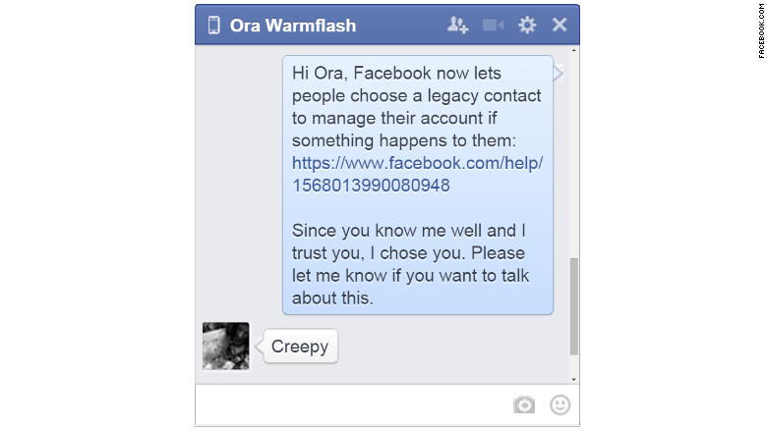

You also have the option to click a button that will give that person access to your posts, photos, videos and information in your "about" section -- basically everything except your personal messages.
If choosing legacy contacts isn't something you're interested in, Facebook also will let you delete your account after you die.

Facebook isn't alone in trying to solve the digital data management problem after you die.
In 2013, Google began allowing people to assign beneficiaries of their Google accounts. The Inactive Account Manager will send you a text message and an email if you haven't logged into Gmail, Google Maps, Google Drive, YouTube or any other Google apps for a set amount of time -- between three months and 18 months.

If you don't respond to Google's alert, Google will send your Google account data to a trusted contact or contacts. You can choose which Google services they're allowed to see -- or you can just delete your account, if you wish.

